**OOP – Assignment 6**

**Operator Overloading**

You are given a cpp file “YourRollNumber.cpp” which contains partial definition of class “MyString” and a driver program Main. Your task is to complete the definition of MyString such that it gives following output:

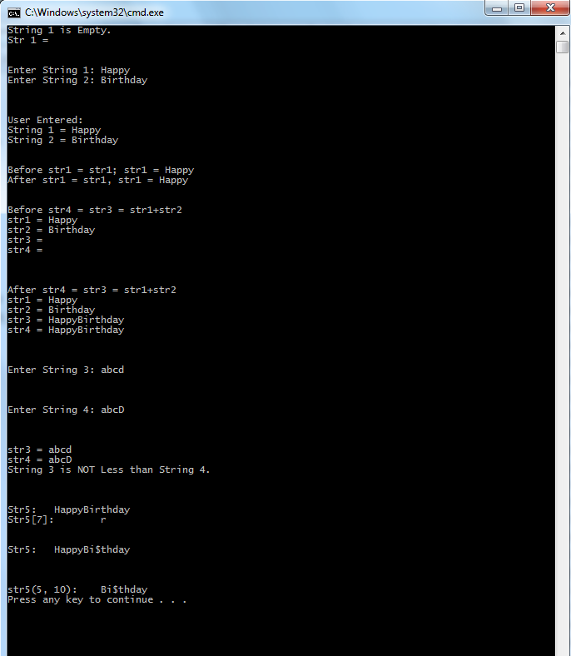

**Important:**

**You are not allowed to change main program.**

**YourRollNo.cpp**

|  |
| --- |
| #include<iostream>  using namespace std;  class MyString  {  //You can add your code here  private:  char* str;  int lenght; //not including the null char here  //Add GetStringFromBuffer as private member (helper)  //Add Concatenate, CompareString as private member (helper)  //You can add your class members here  public:  //-------------DO_NOT_CHANGE REGION starts below---------------------  //Do not change the prototypes given below  MyString operator+(const MyString);  MyString& operator=(const MyString&);  bool operator<(MyString); //Comparison on the basis of ascii values  //-------------End of DO_NOT_CHANGE REGION---------------------  //Add your class members here  };  //--------------------------Add your code here----------------------  //-------------DO_NOT_CHANGE REGION starts below---------------------  void main()  {  MyString str1, str2, str3, str4; //Default constructor will make a string of lenght 0 but having null character (only) i.e. empty string    if(!str1)  {  cout<<"String 1 is Empty.\n";  cout<<"Str 1 = "<<str1<<endl<<endl<<endl;  }    cout << "Enter String 1:\t";  cin >> str1;  cout << "Enter String 2:\t";  cin >> str2;    cout << "\n\n\nUser Entered:\n";  cout << "String 1 = " << str1 << endl;  cout << "String 2 = " << str2 << endl<<endl<<endl;  //What is following code testing?  cout<<"Before str1 = str1; str1 = "<<str1<<endl;  str1 = str1;  cout<<"After str1 = str1, str1 = "<<str1<<endl<<endl<<endl;  cout<<"Before str4 = str3 = str1+str2\n";  cout<<"str1 = "<<str1<<endl;  cout<<"str2 = "<<str2<<endl;  cout<<"str3 = "<<str3<<endl;  cout<<"str4 = "<<str4<<endl;  str4 = str3 = str1+str2;  cout<<"\n\n\nAfter str4 = str3 = str1+str2\n";  cout<<"str1 = "<<str1<<endl;  cout<<"str2 = "<<str2<<endl;  cout<<"str3 = "<<str3<<endl;  cout<<"str4 = "<<str4<<endl;  cout<<"\n\n\nEnter String 3:\t";  cin >> str3;  cout<<"\n\n\nEnter String 4:\t";  cin >> str4;    cout<<"\n\n\nstr3 = "<<str3<<endl;  cout<<"str4 = "<<str4<<endl;  if(str3 < str4)  cout<<"String 3 is Less than String 4.\n";  else  cout<<"String 3 is NOT Less than String 4.\n";  MyString str5 = str1 + str2;  cout << "\n\n\nStr5:\t" << str5 << endl;  cout << "Str5[7]:\t" << str5[7] << endl; //Function Call: str5.operator[](7).  str5[7] = '$';  cout << "\n\nStr5:\t" << str5 << endl;  cout << "\n\n\nstr5(5, 10):\t" << str5(5, 10) << endl;// Substring of lenght 10 starting from index 5 . Function Call str5.operator()(5,10) Let the returned MyString or char* leak    }  //-------------End of DO_NOT_CHANGE REGION--------------------- |